**Part 1:**

1. **Message encrypted with RC4**
   1. Attached.
2. **Screenshot using echo and pipe to encrypt and decrypt**
   1. Encrypt:



* 1. Decrypt: 

1. **Code for each of the three flaws** 
   1. Attached.
2. **First byte of message and key** 
   1. The first byte is 0x63
   2. The key and the message are:

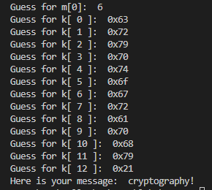

**Part 2:**

1. **Screenshot of decryption command**

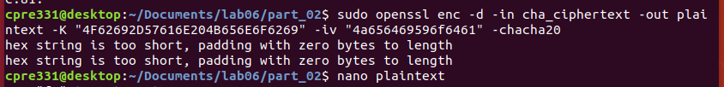



1. **Diffusion bit counts and percentage for quarter round 0**

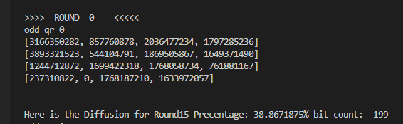

1. **Code for calculating diffusion bit counts and percentage**
   1. Attached